JOB PORTAL MANAGEMENT SYSTEM

A project report submitted in partial fulfillment of the requirements for the completion of Application Development in

Bachelor of Technology
In

Computer Science and Engineering
By
P. Sathvik (2411CS010480)
V. Varshith (2411CS010546)
T. Ranadheer (2411CS010549)



Department of Computer Science & Engineering MALLA REDDY UNIVERSITY, HYDERABAD
2025-2026



CERTIFICATE

This is to certify that this is the Application Development Lab Record entitled “ JOB PORTAL MANAGEMENT SYSTEM”, submitted by P. Sathvik (2411CS010417), V. Varshith (2411CS010157), T. RANADHEER (2411CS010549), , B.Tech II Year II Semester, Department of CSE during the academic year 2025–26. The results embodied in this report have not been submitted to any other university or institute for the award of any degree or diploma.

Internal Guide | DEAN CSE

External Examiner



DECLARATION

I declare that this project report titled “JOB PORTAL MANAGEMENT SYSTEM”, submitted in partial fulfillment of the degree of B.Tech in Computer Science and Engineering, is a record of original work carried out by me under the supervision of Mrs.
G. Devi Priya, and has not formed the basis for the award of any other degree or diploma in this or any other institution or university. In keeping with the ethical practice in reporting scientific information, due acknowledgements have been made wherever the findings of others have been cited.

P. Sathvik (2411CS010417)
V.varshith (2411CS010546)
T. Ranadheer (2411CS010549)

ACKNOWLEDGEMENT
It gives me immense pleasure to express my profound gratitude to all those who extended their valuable support, encouragement, and guidance in the successful completion of this project.

First and foremost, we would like to express my heartfelt thanks to Dr. V. S. K. Reddy, Hon’ble Vice-Chancellor of our esteemed institution, for providing an excellent academic environment, necessary facilities, and constant encouragement that motivated me to pursue this project with enthusiasm and dedication. His inspiring leadership has always been a source of motivation for all students.

We deeply indebted to Dean, Department of Computer Science and Engineering, for his valuable support, expert advice, and continuous encouragement throughout the course of this project. His guidance and concern for students have greatly contributed to the successful completion of this work.
We wish to express my sincere appreciation and heartfelt gratitude to our project guide, for their invaluable guidance, constructive suggestions, and constant supervision during every phase of this project. Their technical expertise, insightful feedback, and encouragement were instrumental in shaping this work and bringing it to completion.

We also extend my thanks to all the faculty members of the Department of Computer Science and Engineering for their cooperation and assistance whenever required.

Finally, we express my deep gratitude to my parents, friends, and well-wishers for their unwavering support, patience, and motivation throughout this journey. Their encouragement has been the driving force behind the successful completion of this project.

ABSTRACT
The Job Portal Management System is a web-based application developed to simplify and automate the recruitment process by providing a common platform for recruiters, job seekers, and administrators. Traditional recruitment methods are often time-consuming, require significant manual effort, and make it difficult for employers to manage job postings and applications efficiently. This system addresses these challenges by offering a centralized platform where recruiters can post job vacancies, job seekers can search and apply for jobs, and administrators can manage users and monitor overall system activities.
The application is developed using Java, Spring Boot, Spring MVC, Spring Security, Thymeleaf, HTML, CSS, Bootstrap, JavaScript, and MySQL. It follows the MVC (Model–View–Controller) architecture to ensure maintainability, scalability, and better code organization. Spring Security provides secure authentication and role-based authorization for different users, ensuring that each user can access only the features assigned to their role.
The system includes three main modules: Admin, Recruiter, and Job Seeker. Recruiters can create company profiles, post new jobs, edit or delete existing job listings, and manage applicants. Job seekers can register, log in, browse available jobs, apply for suitable positions, and track their applications. Administrators can manage users, recruiters, companies, job postings, and monitor overall system performance through an administrative dashboard.
The Job Portal Management System provides a user-friendly interface, secure authentication, efficient job management, and streamlined recruitment operations. It reduces paperwork, minimizes manual processing, improves communication between recruiters and candidates, and enhances the overall hiring experience. The project demonstrates the practical implementation of modern Java web technologies to build a secure, reliable, and scalable recruitment platform suitable for educational purposes as well as real-world applications.

TABLE OF CONTENT

DESCRIPTION | PAGE NUMBER
CERTIFICATE | II
DECLARATION | III
ACKNOWLEDGEMENTS | IV
ABSTRACT | V
LIST OF FIGURES | VI
LIST OF TABLES | VII
- Introduction | 1
1.1 Introduction | 1
- Problem Statement  - Objective of Project  - Goal of Project | 2  2  3
- LITERATURE REVIEW | 4
- PROBLEM STATEMENT | 5
- OBJECTIVES | 6
- Requirements | 7
Software Requirements | 7
Hardware requirements | 7
6. Design and Modules | 8
System Architecture & Data Flow  7.Methodology | 8  9

8. Implementation and Results | 12
Coding | 12
Screen Shots | 50
9. Results | 54
- Conclusion | 55

LIST OF FIGURES

FIGURE NO. | NAME OF THE FIGURE | PAGE NO.
Fig. 1 | System Architecture | 9
Fig. 2 | Data Flow Diagram | 10
Fig. 3 | Job portal page | 50
Fig. 4 | Role Login Page | 50
Fig. 5 | Seeker dashboard page | 51
Fig. 6 | Find Job | 51
Fig. 7 | Manage Job | 52
Fig. 8 | Admin Page | 52

  - Introduction

INTRODUCON

The Job Portal Management System is a web-based application designed to simplify and modernize the recruitment process by connecting job seekers and recruiters through a single online platform. In today's competitive job market, organizations require an efficient system to advertise job vacancies, receive applications, and manage candidates, while job seekers need an easy and convenient way to search and apply for suitable job opportunities. This project fulfills these requirements by providing a secure, reliable, and user-friendly recruitment platform.
The system is developed using Java Spring Boot as the backend framework, Spring MVC for handling web requests, Spring Security for authentication and authorization, Thymeleaf for dynamic web pages, HTML, CSS, Bootstrap, and JavaScript for the user interface, and MySQL as the database. The application follows the Model-View-Controller (MVC) architecture, which improves code organization, maintainability, and scalability.

Problem Statement
The traditional recruitment process is largely manual, time-consuming, and inefficient for both employers and job seekers. Companies often use multiple platforms or paper-based methods to advertise vacancies, collect resumes, and manage applicants. This makes it difficult to organize candidate information, track applications, and communicate effectively with job seekers. Similarly, job seekers must visit different websites or company portals to search for jobs and submit applications, making the process complicated and time-consuming.
Many existing recruitment systems also lack proper role-based access, centralized management, secure authentication, and an easy-to-use interface. Recruiters face challenges in posting, updating, and managing job vacancies, while administrators struggle to monitor users and maintain system data efficiently. As the number of applicants increases, manual handling of recruitment activities becomes more difficult and prone to errors.

Objective of Project
The primary objective of the Job Portal Management System is to develop a secure, efficient, and user-friendly web application that simplifies the recruitment process for administrators, recruiters, and job seekers. The system aims to provide a centralized platform where recruiters can post and manage job vacancies, while job seekers can search for suitable jobs and apply online with ease. It also enables administrators to monitor and manage users, companies, job postings, and applications efficiently through a dedicated dashboard. The application is designed to reduce manual paperwork, improve the speed and accuracy of recruitment, and provide secure role-based authentication using Spring Security. By utilizing modern technologies such as Java, Spring Boot, Spring MVC, Thymeleaf, HTML, CSS, Bootstrap, JavaScript, and MySQL, the system ensures reliability, scalability, and maintainability. Overall, the project enhances communication between recruiters and job seekers, streamlines the hiring process, and provides an effective online recruitment solution suitable for educational and real-world applications.
The primary objective of the Job Portal Management System is to develop a secure, efficient, and user-friendly web application that simplifies the recruitment process for administrators, recruiters, and job seekers. The system aims to provide a centralized platform where recruiters can post and manage job vacancies, while job seekers can search for suitable jobs and apply online with ease. It also enables administrators to monitor and manage users, companies, job postings, and applications efficiently through a dedicated dashboard. The application is designed to reduce manual paperwork, improve the speed and accuracy of recruitment, and provide secure role-based authentication using Spring Security. By utilizing modern technologies such as Java, Spring Boot, Spring MVC, Thymeleaf, HTML, CSS, Bootstrap, JavaScript, and MySQL, the system ensures reliability, scalability, and maintainability. Overall, the project enhances communication between recruiters and job seekers, streamlines the hiring process, and provides an effective online recruitment solution suitable for educational and real-world applications.

Goal Of Project

The goal of the Job Portal Management System is to develop a secure, efficient, and user-friendly web application that streamlines the recruitment process by connecting job seekers and recruiters on a single platform. The project aims to automate recruitment activities such as user registration, job posting, job searching, online applications, and applicant management, thereby reducing manual effort and paperwork. It also seeks to provide role-based access for administrators, recruiters, and job seekers to ensure secure and organized system operations. By using modern technologies such as Java, Spring Boot, Spring Security, Thymeleaf, HTML, CSS, Bootstrap, JavaScript, and MySQL, the project aims to deliver a scalable, reliable, and maintainable solution that improves communication between employers and candidates, enhances the hiring process, and provides a strong foundation for future enhancements such as AI-based job recommendations, email notifications, and interview scheduling.

2. LITERATURE REVIEW
Traditional vehicle rental systems suffer from inaccurate and static pricing as their most significant problem. These systems use fixed pricing models where each vehicle is assigned a static daily or hourly rate that remains unchanged for months or years, meaning a vehicle manufactured in 2018 is priced the same as an identical model from 2024. This fails to account for depreciation, where vehicle value decreases by approximately 8% each year, causing owners to either lose revenue by pricing too low or lose customers by pricing too high. Seasonal demand variations during festivals, weddings, holidays, or summer vacations are completely ignored, leading to missed revenue opportunities during peak seasons and low utilization during off-seasons. Additionally, manual estimation systems require owners to research competitor prices and update listings manually, a process that is time-consuming, error-prone, and inconsistent. By the time an owner notices market changes, optimal pricing opportunities are already lost.

Another critical problem is the inability of existing systems to process unstructured data such as vehicle feature descriptions and market sentiment. A vehicle with a sunroof, ADAS, leather seats, premium sound system, or 360-degree camera should be priced higher than an identical model without these features, yet traditional systems have no mechanism to recognize or value these features. Market sentiment such as increased demand for SUVs during monsoon season, higher demand for electric vehicles in metropolitan cities, or lower demand for diesel vehicles in pollution-controlled areas is completely ignored. Rule-based dynamic pricing systems used by larger platforms operate on predefined rules like "increase price by 20% on weekends" but cannot learn from historical data, identify complex patterns, or improve over time. When market conditions change, rules must be updated manually, and there is no mechanism for continuous improvement based on booking success rates, customer feedback, or competitor price changes.

The lack of an integrated role-based platform further compounds these problems. Most existing solutions are fragmented, with some platforms providing basic vehicle listing and booking but no intelligent pricing, while others offer price suggestions but no complete rental management features. No single system integrates ML-based price prediction, AI-based refinement, owner dashboards for listing management, customer dashboards for browsing and booking, and admin dashboards for monitoring and control.

3.PROBLEM STATEMENT

The traditional recruitment process is often manual, time-consuming, and inefficient for both recruiters and job seekers. Companies usually rely on multiple platforms or manual methods to advertise job vacancies, collect resumes, and manage applicants, making it difficult to organize candidate information and track the recruitment process effectively. Similarly, job seekers face challenges in searching for suitable job opportunities, submitting applications to different companies, and monitoring their application status. These issues result in increased paperwork, delayed communication, and reduced efficiency in the hiring process.
The Job Portal Management System is proposed to overcome these limitations by providing a centralized, secure, and user-friendly web application. The system enables recruiters to post and manage job vacancies, job seekers to search and apply for jobs online, and administrators to manage users, companies, and overall system activities. By automating recruitment tasks and implementing role-based authentication, the application reduces manual effort, improves data security, enhances communication between employers and candidates, and provides an efficient solution for modern online recruitment.

4.OBJECTIVES

The primary objective of the Job Portal Management System is to develop a secure, efficient, and user-friendly web application that simplifies and automates the recruitment process by providing a centralized platform for administrators, recruiters, and job seekers. The system is designed to eliminate the limitations of traditional recruitment methods by enabling organizations to post job vacancies online and allowing candidates to search and apply for jobs from anywhere. It aims to reduce manual paperwork, minimize processing time, improve communication between recruiters and applicants, and ensure transparency throughout the hiring process.
Another important objective of the project is to implement role-based authentication and authorization, ensuring that each user can access only the features assigned to their role. The Administrator is responsible for managing users, recruiters, companies, and job postings, while Recruiters can create company profiles, post new jobs, edit or delete job listings, and manage applicants. Job Seekers can register, log in securely, search for jobs based on their qualifications and interests, upload resumes, apply for suitable positions, and track the status of their applications. This role-based approach improves system security, organization, and efficiency.
The project also aims to provide a responsive and attractive user interface using HTML, CSS, Bootstrap, JavaScript, and Thymeleaf, while the backend is developed using Java, Spring Boot, Spring MVC, and Spring Security. MySQL is used as the database to securely store user information, company details, job postings, and application records. The application follows the Model-View-Controller (MVC) architecture, ensuring modularity, maintainability, and scalability. Data validation, secure password encryption, and efficient database management further enhance the reliability of the system.
Furthermore, the Job Portal Management System seeks to improve the overall recruitment experience by automating repetitive tasks, reducing administrative workload, and enabling faster hiring decisions. The project serves as a practical implementation of modern Java web technologies and demonstrates the development of an enterprise-level web application. It also provides a strong foundation for future enhancements such as AI-based job recommendations, resume screening, interview scheduling, email notifications, and analytics dashboards, making it suitable for both academic learning and real-world recruitment applications.

5.SOFTWARE AND HARDWARE REQUIREMENTS

Software Requirements

• Frontend: HTML5, CSS3, Bootstrap 5, JavaScript, Thymeleaf
• Backend: Java, Spring Boot, Spring MVC, Spring Security
• Database: MySQL 8.0
• Build Tool: Maven
• IDE: Spring Tool Suite (STS) / IntelliJ IDEA / Eclipse
• Server: Apache Tomcat (Embedded in Spring Boot)
• Version Control: Git and GitHub
• Operating System: Windows 10/11, Linux, or macOS
• Web Browser: Google Chrome, Mozilla Firefox, Microsoft Edge

Hardware requirements

• Processor: Intel Core i5 or above (or equivalent AMD processor)
• RAM: Minimum 8 GB (16 GB recommended)
• Storage: At least 20 GB free disk space (SSD recommended)
• Display: 1366 × 768 resolution or higher
• Internet Connection: Required for downloading dependencies, updates, and project deployment
• Keyboard and Mouse: Standard input devices

6.SYSTEM DESIGN AND MODULES

System Architecture

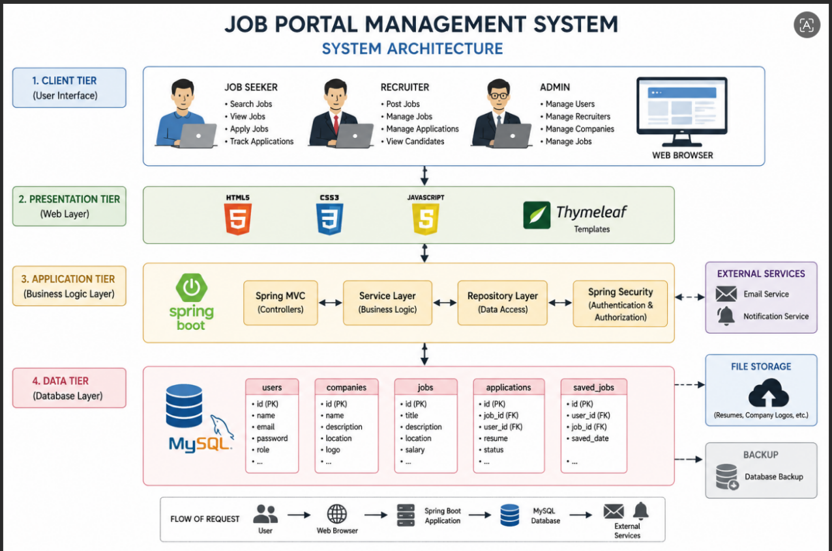

Fig.1: System Architecture

Data Flow Diagram

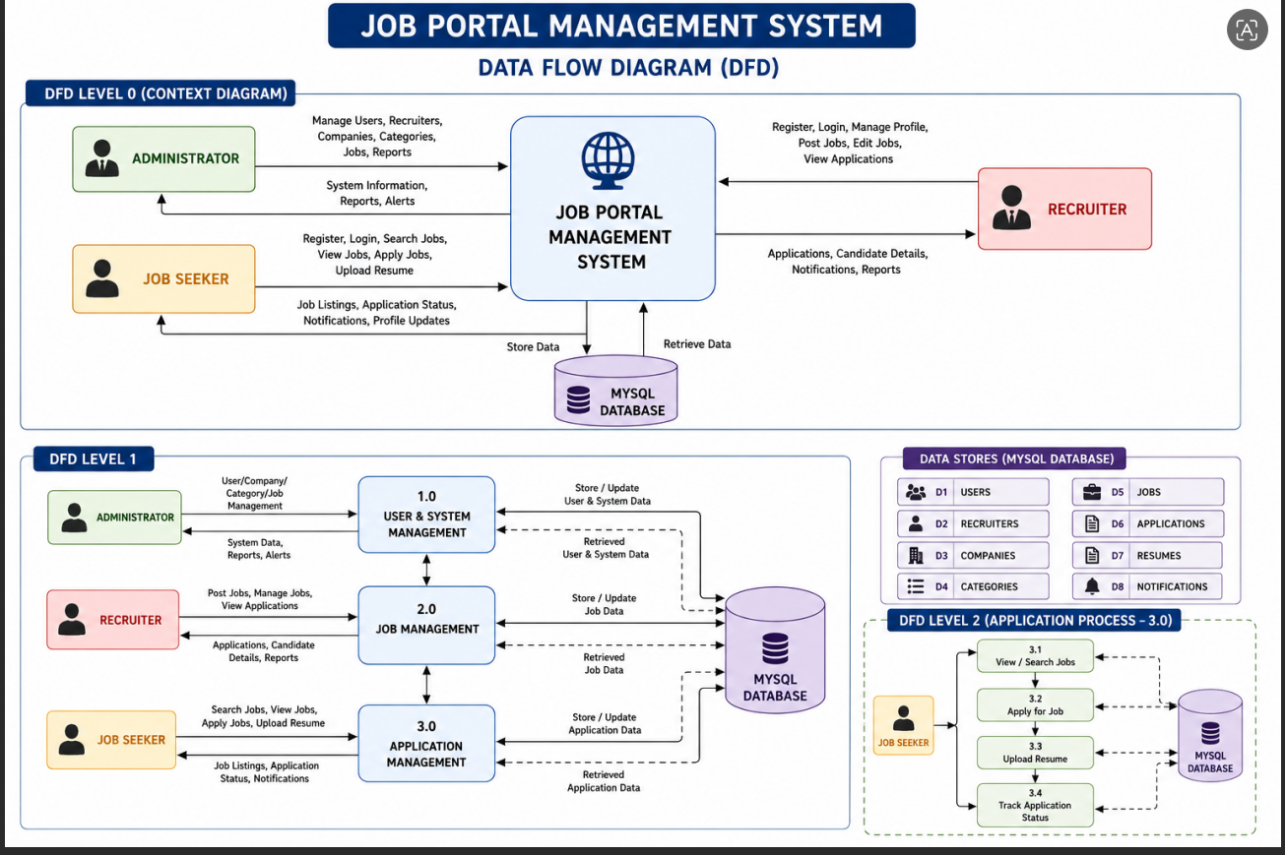

Fig. 2: Data Flow Diagram

7.METHODOLOGY

The Job Portal Management System is developed using a systematic software development methodology to ensure that the application is secure, reliable, and easy to maintain. The development process begins with requirement analysis, where the functional and non-functional requirements of the system are identified. The main users of the application are the Administrator, Recruiter, and Job Seeker, and their respective functionalities are carefully analyzed before the development process begins.
After gathering the requirements, the system design phase is carried out. During this stage, the overall architecture of the application, database schema, user interfaces, and module interactions are designed. The application follows the Model-View-Controller (MVC) architecture, which separates the user interface, business logic, and database operations into different layers for better maintainability and scalability.
The implementation phase involves developing the frontend using HTML, CSS, Bootstrap, JavaScript, and Thymeleaf, while the backend is built using Java, Spring Boot, Spring MVC, and Spring Security. The MySQL database is used to store user details, company information, job postings, and application records securely. Spring Security provides user authentication and role-based authorization, ensuring that only authorized users can access specific features.
Once the application is developed, testing is performed to verify the functionality of each module. Unit testing, integration testing, and functional testing are conducted to identify and fix errors, ensuring that the system operates correctly and securely. Database operations, user authentication, job posting, and job application functionalities are thoroughly tested before deployment.
Finally, the application is deployed on a web server, allowing users to access the system through a web browser. The developed Job Portal Management System provides a secure, scalable, and user-friendly platform that simplifies recruitment by enabling recruiters to manage job postings, job seekers to apply for jobs online, and administrators to monitor and manage the overall system efficiently.

8.IMPLEMENTATION AND RESULTS

Coding

Login Page:
<!DOCTYPE html>
<html lang="en" xmlns:th="http://www.thymeleaf.org">
<head>
<meta charset="UTF-8">
<meta name="viewport"
content="width=device-width, initial-scale=1.0">
<title>Login | Job Portal</title>
<!-- Google Font -->
<link href="https://fonts.googleapis.com/css2?family=Poppins:wght@300;400;500;600;700&display=swap"
rel="stylesheet">
<!-- Bootstrap -->
<link href="https://cdn.jsdelivr.net/npm/bootstrap@5.3.3/dist/css/bootstrap.min.css"
rel="stylesheet">
<!-- Font Awesome -->
<link rel="stylesheet"
href="https://cdnjs.cloudflare.com/ajax/libs/font-awesome/6.6.0/css/all.min.css">
<link rel="stylesheet"
th:href="@{/css/login.css}">
</head>
<body>
<div class="login-container">
<div class="login-card">
<!-- Left Panel -->
<div class="left-panel">
<h1>Welcome Back</h1>
<p>
Login to access your dashboard,
apply for jobs and manage your career.
</p>
<img th:src="@{/images/login.png}" alt="Login">
</div>
<!-- Right Panel -->
<div class="right-panel">
<h2>Sign In</h2>
<form th:action="@{/login}" method="post">
<!-- Login Error -->
<div th:if="${param.error}" class="alert alert-danger">
Invalid Email, Password or Role.
</div>
<!-- Logout -->
<div th:if="${param.logout}" class="alert alert-success">
You have been logged out successfully.
</div>
<!-- Password Reset -->
<div th:if="${param.resetSuccess}" class="alert alert-success">
Password changed successfully.
Please login using your new password.
</div>
<div class="mb-3">
<label>Email</label>
<input
type="email"
name="username"
class="form-control"
placeholder="Enter Email"
required>
</div>
<div class="mb-3">
<label>Password</label>
<input
type="password"
name="password"
class="form-control"
placeholder="Enter Password"
required>
</div>
<div class="mb-3">
<label>Login As</label>
<select
name="role"
class="form-select"
required>
<option value="">Select Role</option>
<option value="JOB_SEEKER">
Job Seeker
</option>
<option value="RECRUITER">
Recruiter
</option>
<option value="ADMIN">
Admin
</option>
</select>
</div>
<div class="d-flex justify-content-between align-items-center">
<div>
<input
type="checkbox"
name="remember-me">
Remember Me
</div>
<a th:href="@{/forgot-password}">
Forgot Password?
</a>
</div>
<button
type="submit"
class="btn btn-success w-100 mt-4">
Login
</button>
<p class="text-center mt-4">
Don't have an account?
<a th:href="@{/register}">
Register
</a>
</p>
</form>
</div>
</div>
</div>
</body>
</html>

Register.html
<!DOCTYPE html>
<html lang="en" xmlns:th="http://www.thymeleaf.org">
<head>
<meta charset="UTF-8">
<meta name="viewport" content="width=device-width, initial-scale=1.0">
<title>Job Portal | Register</title>
<link rel="stylesheet" th:href="@{/css/register.css}">
</head>
<body>
<div class="container">
<div class="register-card">
<!-- Left Side -->
<div class="left-side">
<h1>Welcome!</h1>
<p>
Create your Job Portal account to discover thousands of jobs,
connect with recruiters and build your dream career.
</p>
</div>
<!-- Right Side -->
<div class="right-side">
<h2>User Registration</h2>
<!-- Error Message -->
<div th:if="${error}" class="alert alert-danger">
<span th:text="${error}"></span>
</div>
<form th:action="@{/register}"
th:object="${user}"
method="post">
<label class="form-label">
Full Name
</label>
<input
type="text"
class="form-control"
th:field="*{fullName}"
placeholder="Enter Full Name"
required>
<label class="form-label">
Email
</label>
<input
type="email"
class="form-control"
th:field="*{email}"
placeholder="Enter Email Address"
required>
<label class="form-label">
Password
</label>
<input
type="password"
class="form-control"
th:field="*{password}"
placeholder="Enter Password"
required>
<label class="form-label">
Phone Number
</label>
<input
type="text"
class="form-control"
th:field="*{phone}"
placeholder="Enter Phone Number">
<label class="form-label">
Register As
</label>
<select
class="form-select"
th:field="*{role}"
required>
<option value="">
Select Role
</option>
<option value="JOB_SEEKER">
Job Seeker
</option>
<option value="RECRUITER">
Recruiter
</option>
</select>
<button
type="submit"
class="btn-register">
Create Account
</button>
</form>
<div class="login-link">
Already have an account?
<a th:href="@{/login}">
Login
</a>
</div>
</div>
</div>
</div>
</body>
</html>

Dashboard.html
package com.jobportal.controller;
import org.springframework.stereotype.Controller;
import org.springframework.web.bind.annotation.GetMapping;
@Controller
public class DashboardController {
@GetMapping("/dashboard-home")
public String dashboard() {
return "dashboard";
}
}

ForgetPassword.java
package com.jobportal.controller;
import com.jobportal.entity.User;
import com.jobportal.service.EmailService;
import com.jobportal.service.OtpService;
import com.jobportal.service.UserService;
import org.springframework.beans.factory.annotation.Autowired;
import org.springframework.security.crypto.password.PasswordEncoder;
import org.springframework.stereotype.Controller;
import org.springframework.ui.Model;
import org.springframework.web.bind.annotation.*;
@Controller
public class ForgotPasswordController {
@Autowired
private UserService userService;
@Autowired
private EmailService emailService;
@Autowired
private OtpService otpService;
@Autowired
private PasswordEncoder passwordEncoder;
@GetMapping("/forgot-password")
public String forgotPasswordPage() {
return "forgot-password";
}
@PostMapping("/send-otp")
public String sendOtp(@RequestParam String email,
Model model) {
User user = userService.getUserByEmail(email);
if (user == null) {
model.addAttribute("error",
"Email not found");
return "forgot-password";
}
String otp = otpService.generateOtp(email);
emailService.sendOtp(email, otp);
model.addAttribute("email", email);
return "verify-otp";
}
@PostMapping("/verify-otp")
public String verifyOtp(@RequestParam String email,
@RequestParam String otp,
Model model) {
if (!otpService.verifyOtp(email, otp)) {
model.addAttribute("email", email);
model.addAttribute("error",
"Invalid OTP");
return "verify-otp";
}
model.addAttribute("email", email);
return "reset-password";
}
@PostMapping("/reset-password")
public String resetPassword(@RequestParam String email,
@RequestParam String password) {
User user = userService.getUserByEmail(email);
user.setPassword(passwordEncoder.encode(password));
userService.updateUser(user);
otpService.removeOtp(email);
return "redirect:/login?resetSuccess";
}
}

DashboardController.html
package com.jobportal.controller;
import org.springframework.stereotype.Controller;
import org.springframework.web.bind.annotation.GetMapping;
@Controller
public class DashboardController {
@GetMapping("/dashboard-home")
public String dashboard() {
return "dashboard";
}
}

HomeController.java
package com.jobportal.controller;
import com.jobportal.service.JobService;
import org.springframework.beans.factory.annotation.Autowired;
import org.springframework.stereotype.Controller;
import org.springframework.ui.Model;
import org.springframework.web.bind.annotation.GetMapping;
@Controller
public class HomeController {
@Autowired
private JobService jobService;
@GetMapping("/")
public String home(Model model) {
model.addAttribute("jobs", jobService.getAllJobs());
return "index";
}
}

JobSekeerController.java
package com.jobportal.controller;
import com.jobportal.entity.Application;
import com.jobportal.entity.SavedJob;
import com.jobportal.entity.User;
import com.jobportal.service.ApplicationService;
import com.jobportal.service.SavedJobService;
import com.jobportal.service.UserService;
import org.springframework.beans.factory.annotation.Autowired;
import org.springframework.stereotype.Controller;
import org.springframework.ui.Model;
import org.springframework.web.bind.annotation.GetMapping;
import java.util.List;
@Controller
public class JobSeekerController {
@Autowired
private UserService userService;
@Autowired
private ApplicationService applicationService;
@Autowired
private SavedJobService savedJobService;
@GetMapping("/dashboard")
public String dashboard(Model model) {
// Temporary user
User user = userService.getUserById(1L);
List<Application> applications =
applicationService.getApplicationsByUser(user);
List<SavedJob> savedJobs =
savedJobService.getSavedJobs(user);
long pending =
applications.stream()
.filter(a -> a.getStatus().equals("Pending"))
.count();
long accepted =
applications.stream()
.filter(a -> a.getStatus().equals("Accepted"))
.count();
model.addAttribute("user", user);
model.addAttribute("applications", applications);
model.addAttribute("savedJobs", savedJobs);
model.addAttribute("appliedCount",
applications.size());
model.addAttribute("savedCount",
savedJobs.size());
model.addAttribute("pendingCount",
pending);
model.addAttribute("acceptedCount",
accepted);
return "jobseeker-dashboard";
}
}

Logout.java

package com.jobportal.controller;
import jakarta.servlet.http.HttpServletRequest;
import jakarta.servlet.http.HttpServletResponse;
import org.springframework.security.core.Authentication;
import org.springframework.security.core.context.SecurityContextHolder;
import org.springframework.security.web.authentication.logout.SecurityContextLogoutHandler;
import org.springframework.stereotype.Controller;
import org.springframework.web.bind.annotation.GetMapping;
@Controller
public class LogoutController {
@GetMapping("/logout")
public String logout(HttpServletRequest request,
HttpServletResponse response) {
Authentication authentication =
SecurityContextHolder.getContext().getAuthentication();
if (authentication != null) {
new SecurityContextLogoutHandler().logout(
request,
response,
authentication
);
}
return "redirect:/login?logout";
}
}

RecruiterCampanyControler.java
package com.jobportal.controller;
import jakarta.servlet.http.HttpServletRequest;
import jakarta.servlet.http.HttpServletResponse;package com.jobportal.controller;
import com.jobportal.entity.Company;
import com.jobportal.service.CompanyService;
import org.springframework.beans.factory.annotation.Autowired;
import org.springframework.stereotype.Controller;
import org.springframework.ui.Model;
import org.springframework.web.bind.annotation.*;
@Controller
@RequestMapping("/recruiter/company")
public class RecruiterCompanyController {
@Autowired
private CompanyService companyService;
@GetMapping("/profile")
public String profile(Model model) {
model.addAttribute("company", new Company());
return "company-profile";
}
@PostMapping("/save")
public String save(@ModelAttribute Company company) {
companyService.saveCompany(company);
return "redirect:/recruiter/company/profile?success";
}
}
import org.springframework.security.core.Authentication;
import org.springframework.security.core.context.SecurityContextHolder;
import org.springframework.security.web.authentication.logout.SecurityContextLogoutHandler;
import org.springframework.stereotype.Controller;
import org.springframework.web.bind.annotation.GetMapping;
@Controller
public class LogoutController {
@GetMapping("/logout")
public String logout(HttpServletRequest request,
HttpServletResponse response) {
Authentication authentication =
SecurityContextHolder.getContext().getAuthentication();
if (authentication != null) {
new SecurityContextLogoutHandler().logout(
request,
response,
authentication
);
}
return "redirect:/login?logout";
}
}
RecruiterController.java
package com.jobportal.controller;
import jakarta.servlet.http.HttpServletRequest;
import jakarta.servlet.http.HttpServletResponse;package com.jobportal.controller;
import com.jobportal.entity.Company;package com.jobportal.controller;
import com.jobportal.entity.Job;
import com.jobportal.service.ApplicationService;
import com.jobportal.service.CategoryService;
import com.jobportal.service.CompanyService;
import com.jobportal.service.JobService;
import com.jobportal.service.UserService;
import org.springframework.beans.factory.annotation.Autowired;
import org.springframework.stereotype.Controller;
import org.springframework.ui.Model;
import org.springframework.web.bind.annotation.*;
@Controller
public class RecruiterController {
@Autowired
private JobService jobService;
@Autowired
private ApplicationService applicationService;
@Autowired
private CompanyService companyService;
@Autowired
private UserService userService;
@Autowired
private CategoryService categoryService;
// ==========================
// Recruiter Dashboard
// ==========================
@GetMapping("/recruiter/dashboard")
public String dashboard(Model model) {
model.addAttribute("totalJobs",
jobService.getAllJobs().size());
model.addAttribute("totalApplications",
applicationService.getAllApplications().size());
model.addAttribute("totalCompanies",
companyService.getAllCompanies().size());
model.addAttribute("totalRecruiters",
userService.getAllUsers()
.stream()
.filter(u -> u.getRole().name().equals("RECRUITER"))
.count());
model.addAttribute("jobs",
jobService.getAllJobs());
return "recruiter-dashboard";
}
// ==========================
// Post Job
// ==========================
@GetMapping("/recruiter/post-job")
public String postJob(Model model) {
model.addAttribute("job", new Job());
model.addAttribute("categories",
categoryService.getAllCategories());
return "recruiter-post-job";
}
@PostMapping("/recruiter/post-job")
public String saveJob(@ModelAttribute Job job) {
jobService.saveJob(job);
return "redirect:/recruiter/dashboard";
}
// ==========================
// Applicants
// ==========================
@GetMapping("/recruiter/applicants")
public String applicants(Model model) {
model.addAttribute("applications",
applicationService.getAllApplications());
return "recruiter-applicants";
}
// ==========================
// Accept Application
// ==========================
@GetMapping("/recruiter/application/accept/{id}")
public String acceptApplication(@PathVariable Long id) {
applicationService.updateStatus(id, "Accepted");
return "redirect:/recruiter/applicants";
}
// ==========================
// Reject Application
// ==========================
@GetMapping("/recruiter/application/reject/{id}")
public String rejectApplication(@PathVariable Long id) {
applicationService.updateStatus(id, "Rejected");
return "redirect:/recruiter/applicants";
}
@GetMapping("/recruiter/manage-jobs")
public String manageJobs(Model model) {
model.addAttribute("jobs", jobService.getAllJobs());
return "recruiter-manage-jobs";
}
}
import com.jobportal.service.CompanyService;
import org.springframework.beans.factory.annotation.Autowired;
import org.springframework.stereotype.Controller;
import org.springframework.ui.Model;
import org.springframework.web.bind.annotation.*;
@Controller
@RequestMapping("/recruiter/company")
public class RecruiterCompanyController {
@Autowired
private CompanyService companyService;
@GetMapping("/profile")
public String profile(Model model) {
model.addAttribute("company", new Company());
return "company-profile";
}
@PostMapping("/save")
public String save(@ModelAttribute Company company) {
companyService.saveCompany(company);
return "redirect:/recruiter/company/profile?success";
}
}
import org.springframework.security.core.Authentication;
import org.springframework.security.core.context.SecurityContextHolder;
import org.springframework.security.web.authentication.logout.SecurityContextLogoutHandler;
import org.springframework.stereotype.Controller;
import org.springframework.web.bind.annotation.GetMapping;
@Controller
public class LogoutController {
@GetMapping("/logout")
public String logout(HttpServletRequest request,
HttpServletResponse response) {
Authentication authentication =
SecurityContextHolder.getContext().getAuthentication();
if (authentication != null) {
new SecurityContextLogoutHandler().logout(
request,
response,
authentication
);
}
return "redirect:/login?logout";
}
}
ResumeController.java
package com.jobportal.controller;
import org.springframework.core.io.Resource;
import org.springframework.core.io.UrlResource;
import org.springframework.stereotype.Controller;
import org.springframework.web.bind.annotation.*;
import org.springframework.http.*;
import java.nio.file.*;
@Controller
public class ResumeController {
@GetMapping("/resume/download/{fileName}")
public ResponseEntity<Resource> downloadResume(
@PathVariable String fileName) throws Exception {
Path path = Paths.get("uploads/resume/")
.resolve(fileName);
Resource resource = new UrlResource(path.toUri());
return ResponseEntity.ok()
.header(HttpHeaders.CONTENT_DISPOSITION,
"attachment; filename=\"" + fileName + "\"")
.body(resource);
}
}
SearchController.java
package com.jobportal.controller;
import com.jobportal.entity.Job;
import com.jobportal.service.JobService;
import org.springframework.beans.factory.annotation.Autowired;
import org.springframework.stereotype.Controller;
import org.springframework.ui.Model;
import org.springframework.web.bind.annotation.*;
import java.util.List;
@Controller
public class SearchController {
@Autowired
private JobService jobService;
@GetMapping("/jobs/search")
public String searchJobs(
@RequestParam(required = false) String title,
@RequestParam(required = false) String location,
@RequestParam(required = false) String company,
Model model) {
List<Job> jobs;
if (title != null && !title.isEmpty()) {
jobs = jobService.searchByTitle(title);
} else if (location != null && !location.isEmpty()) {
jobs = jobService.searchByLocation(location);
} else if (company != null && !company.isEmpty()) {
jobs = jobService.searchByCompany(company);
} else {
jobs = jobService.getAllJobs();
}
model.addAttribute("jobs", jobs);
return "jobs";
}
}
UserController.java
package com.jobportal.controller;
import com.jobportal.entity.User;
import com.jobportal.service.UserService;
import org.springframework.beans.factory.annotation.Autowired;
import org.springframework.stereotype.Controller;
import org.springframework.ui.Model;
import org.springframework.web.bind.annotation.*;
@Controller
public class UserController {
@Autowired
private UserService userService;
@GetMapping("/register")
public String registerPage(Model model) {
model.addAttribute("user", new User());
return "register";
}
@PostMapping("/register")
public String registerUser(@ModelAttribute User user) {
userService.saveUser(user);
return "redirect:/login";
}
@GetMapping("/login")
public String loginPage() {
return "login";
}
}
Admin-Campanies.html
<!DOCTYPE html>
<html xmlns:th="http://www.thymeleaf.org">
<head>
<meta charset="UTF-8">
<title>Manage Companies</title>
<link href="https://cdn.jsdelivr.net/npm/bootstrap@5.3.3/dist/css/bootstrap.min.css" rel="stylesheet">
</head>
<body>
<div class="container mt-5">
<div class="card shadow p-4">
<h2 class="mb-4">Manage Companies</h2>
<table class="table table-bordered table-hover">
<thead class="table-dark">
<tr>
<th>ID</th>
<th>Company</th>
<th>Email</th>
<th>Phone</th>
<th>Industry</th>
<th>Action</th>
</tr>
</thead>
<tbody>
<tr th:each="company : ${companies}">
<td th:text="${company.id}"></td>
<td th:text="${company.companyName}"></td>
<td th:text="${company.email}"></td>
<td th:text="${company.phone}"></td>
<td th:text="${company.industry}"></td>
<td>
<a class="btn btn-danger btn-sm"
</a>
</td>
</tr>
</tbody>
</table>
</div>
</div>
</body>
</html>

Admin-campanies.html
<!DOCTYPE html>
<html xmlns:th="http://www.thymeleaf.org">
<head>
<meta charset="UTF-8">
<title>Manage Companies</title>
<link href="https://cdn.jsdelivr.net/npm/bootstrap@5.3.3/dist/css/bootstrap.min.css"
rel="stylesheet">
<link rel="stylesheet"
th:href="@{/css/admin-companies.css}">
</head>
<body>
<div class="container py-5">
<h2 class="mb-4">
Company Management
</h2>
<div class="mb-3">
<a class="btn btn-primary"
th:href="@{/admin/company/add}">
+ Add Company
</a>
<a class="btn btn-secondary"
th:href="@{/admin/dashboard}">
Back
</a>
</div>
<div class="card shadow">
<div class="card-body">
<table class="table table-hover">
<thead class="table-dark">
<tr>
<th>ID</th>
<th>Logo</th>
<th>Company</th>
<th>Email</th>
<th>Website</th>
<th>Location</th>
<th>Action</th>
</tr>
</thead>
<tbody>
<tr th:each="company : ${companies}">
<td th:text="${company.id}"></td>
<td>
<img th:if="${company.logo!=null}"
th:src="@{'/uploads/company/'+${company.logo}}"
width="60"
height="60"
class="rounded">
</td>
<td th:text="${company.name}"></td>
<td th:text="${company.email}"></td>
<td>
<a th:href="${company.website}"
target="_blank">
Visit
</a>
</td>
<td th:text="${company.location}"></td>
<td>
<a class="btn btn-warning btn-sm"
th:href="@{'/admin/company/edit/'+${company.id}}">
Edit
</a>
<a class="btn btn-danger btn-sm"
onclick="return confirm('Delete Company?')"
th:href="@{'/admin/company/delete/'+${company.id}}">
Delete
</a>
</td>
</tr>
</tbody>
</table>
</div>
</div>
</div>
</body>
</html>
Job-details.html
<!DOCTYPE html>
<html lang="en" xmlns:th="http://www.thymeleaf.org">
<head>
<meta charset="UTF-8">
<meta name="viewport" content="width=device-width, initial-scale=1">
<title>Job Details</title>
<link href="https://cdn.jsdelivr.net/npm/bootstrap@5.3.3/dist/css/bootstrap.min.css"
rel="stylesheet">
</head>
<body>
<div class="container mt-5">
<div class="card shadow">
<div class="card-header bg-primary text-white">
<h2 th:text="${job.title}"></h2>
</div>
<div class="card-body">
<table class="table table-bordered">
<tr>
<th width="30%">Company</th>
<td th:text="${job.company}"></td>
</tr>
<tr>
<th>Location</th>
<td th:text="${job.location}"></td>
</tr>
<tr>
<th>Salary</th>
<td th:text="${job.salary}"></td>
</tr>
<tr>
<th>Experience Required</th>
<td th:text="${job.experience}"></td>
</tr>
<tr>
<th>Education</th>
<td th:text="${job.education}"></td>
</tr>
<tr>
<th>Required Skills</th>
<td th:text="${job.skills}"></td>
</tr>
<tr>
<th>No. of Vacancies</th>
<td th:text="${job.vacancies}"></td>
</tr>
<tr>
<th>Employment Type</th>
<td th:text="${job.employmentType}"></td>
</tr>
<tr>
<th>Application Deadline</th>
<td th:text="${job.applicationDeadline}"></td>
</tr>
<tr>
<th>Category</th>
<td th:text="${job.category != null ? job.category.name : 'Not Available'}"></td>
</tr>
</table>
<h4 class="mt-4">Job Description</h4>
<p th:text="${job.description}"></p>
<hr>
<div class="mt-4">
<a th:href="@{'/apply/' + ${job.id}}"
class="btn btn-success">
Apply Job
</a>
<a th:href="@{'/save-job/' + ${job.id}}"
class="btn btn-warning">
Save Job
</a>
<a th:href="@{/jobs}"
class="btn btn-secondary">
Back
</a>
</div>
</div>
</div>
</div>
</body>
</html>
Job-sekeer.html
<!DOCTYPE html>
<html lang="en" xmlns:th="http://www.thymeleaf.org">
<head>
<meta charset="UTF-8">
<meta name="viewport" content="width=device-width, initial-scale=1">
<title>Job Details</title>
<link href="https://cdn.jsdelivr.net/npm/bootstrap@5.3.3/dist/css/bootstrap.min.css"
rel="stylesheet">
</head>
<body>
<div class="container mt-5">
<div class="card shadow">
<div class="card-header bg-primary text-white">
<h2 th:text="${job.title}"></h2>
</div>
<div class="card-body">
<table class="table table-bordered">
<tr>
<th width="30%">Company</th>
<td th:text="${job.company}"></td>
</tr>
<tr>
<th>Location</th>
<td th:text="${job.location}"></td>
</tr>
<tr>
<th>Salary</th>
<td th:text="${job.salary}"></td>
</tr>
<tr>
<th>Experience Required</th>
<td th:text="${job.experience}"></td>
</tr>
<tr>
<th>Education</th>
<td th:text="${job.education}"></td>
</tr>
<tr>
<th>Required Skills</th>
<td th:text="${job.skills}"></td>
</tr>
<tr>
<th>No. of Vacancies</th>
<td th:text="${job.vacancies}"></td>
</tr>
<tr>
<th>Employment Type</th>
<td th:text="${job.employmentType}"></td>
</tr>
<tr>
<th>Application Deadline</th>
<td th:text="${job.applicationDeadline}"></td>
</tr>
<tr>
<th>Category</th>
<td th:text="${job.category != null ? job.category.name : 'Not Available'}"></td>
</tr>
</table>
<h4 class="mt-4">Job Description</h4>
<p th:text="${job.description}"></p>
<hr>
<div class="mt-4">
<a th:href="@{'/apply/' + ${job.id}}"
class="btn btn-success">
Apply Job
</a>
<a th:href="@{'/save-job/' + ${job.id}}"
class="btn btn-warning">
Save Job
</a>
<a th:href="@{/jobs}"
class="btn btn-secondary">
Back
</a>
</div>
</div>
</div>
</div>
</body>
</html>
Manage-jobs.html
<!DOCTYPE html>
<html xmlns:th="http://www.thymeleaf.org">
<head>
<meta charset="UTF-8">
<title>Manage Jobs</title>
<link href="https://cdn.jsdelivr.net/npm/bootstrap@5.3.3/dist/css/bootstrap.min.css" rel="stylesheet">
</head>
<body>
<div class="container mt-5">
<h2 class="mb-4">Manage Jobs</h2>
<table class="table table-bordered table-hover shadow">
<thead class="table-dark">
<tr>
<th>Job Title</th>
<th>Company</th>
<th>Location</th>
<th>Salary</th>
<th>Experience</th>
<th>Vacancies</th>
<th>Action</th>
</tr>
</thead>
<tbody>
<tr th:if="${#lists.isEmpty(jobs)}">
<td colspan="7" class="text-center">
No Jobs Available
</td>
</tr>
<tr th:each="job : ${jobs}">
<td th:text="${job.title}"></td>
<td th:text="${job.company}"></td>
<td th:text="${job.location}"></td>
<td th:text="${job.salary}"></td>
<td th:text="${job.experience}"></td>
<td th:text="${job.vacancies}"></td>
<td>
<a th:href="@{'/recruiter/edit-job/' + ${job.id}}"
class="btn btn-warning btn-sm">
Edit
</a>
<a th:href="@{'/recruiter/delete-job/' + ${job.id}}"
class="btn btn-danger btn-sm"
onclick="return confirm('Delete this job?');">
Delete
</a>
</td>
</tr>
</tbody>
</table>
<a th:href="@{/recruiter/dashboard}" class="btn btn-secondary">
Back
</a>

ScreenShots

Job portal

Job 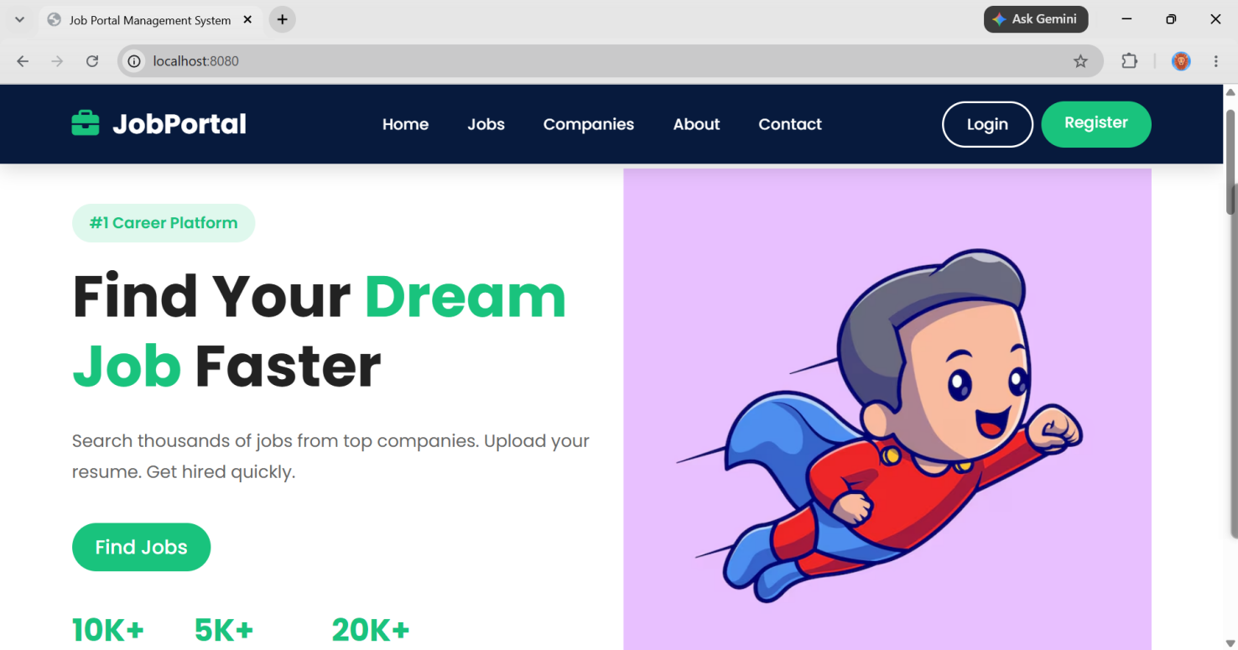

Fig:3
Role Login Page
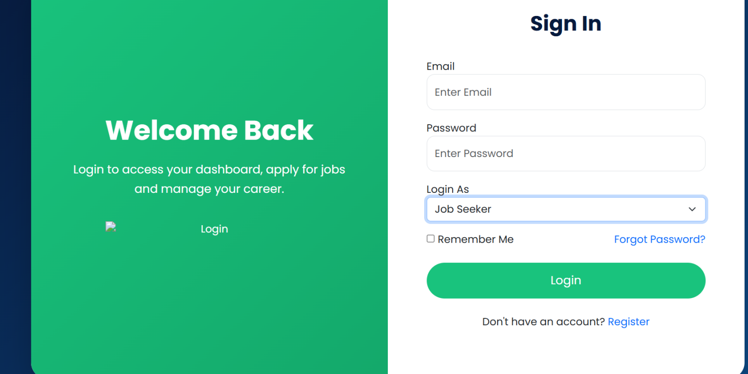

Fig:4

Seeker dashboard Page:
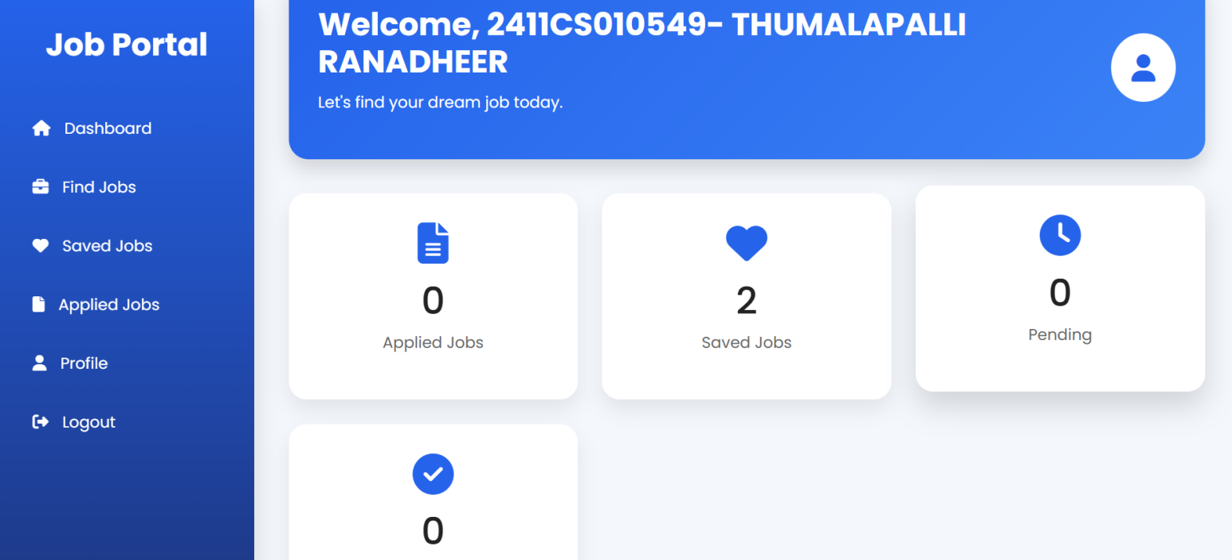

Fig:5

Finding Job

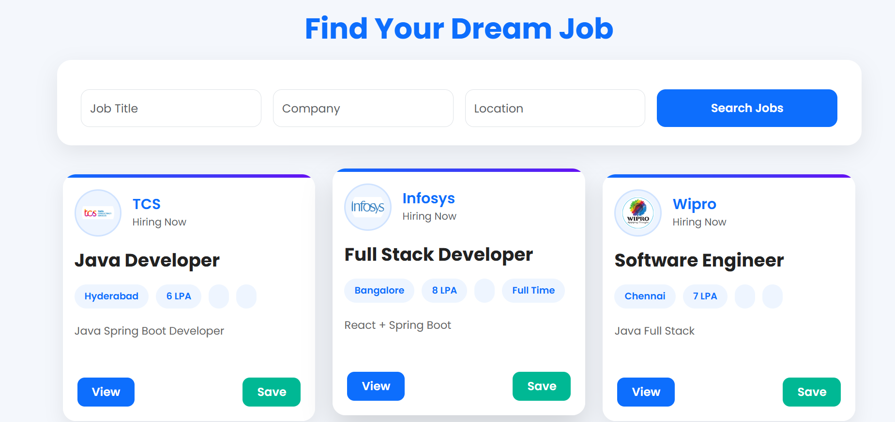

Fig:6

Recruiter dashboard page

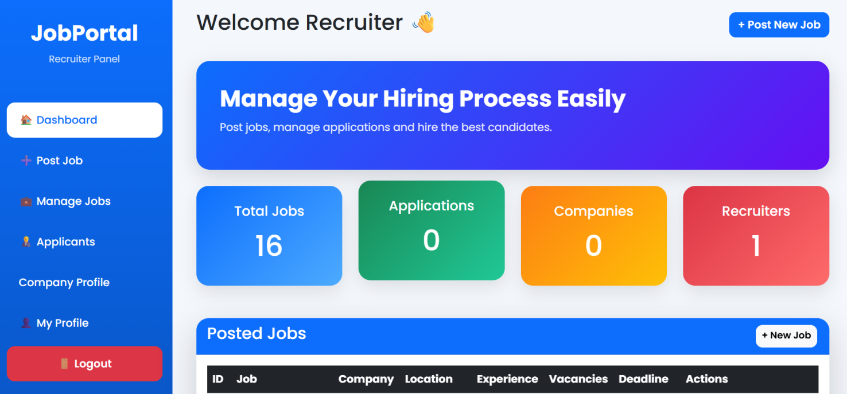

Fig:7

Post Job:

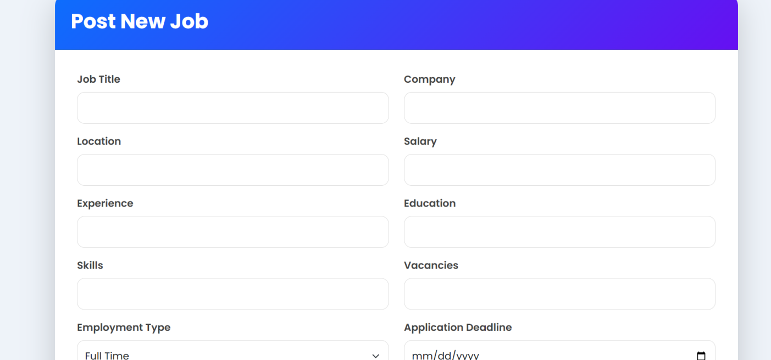

Fig:8

Manage Jobs

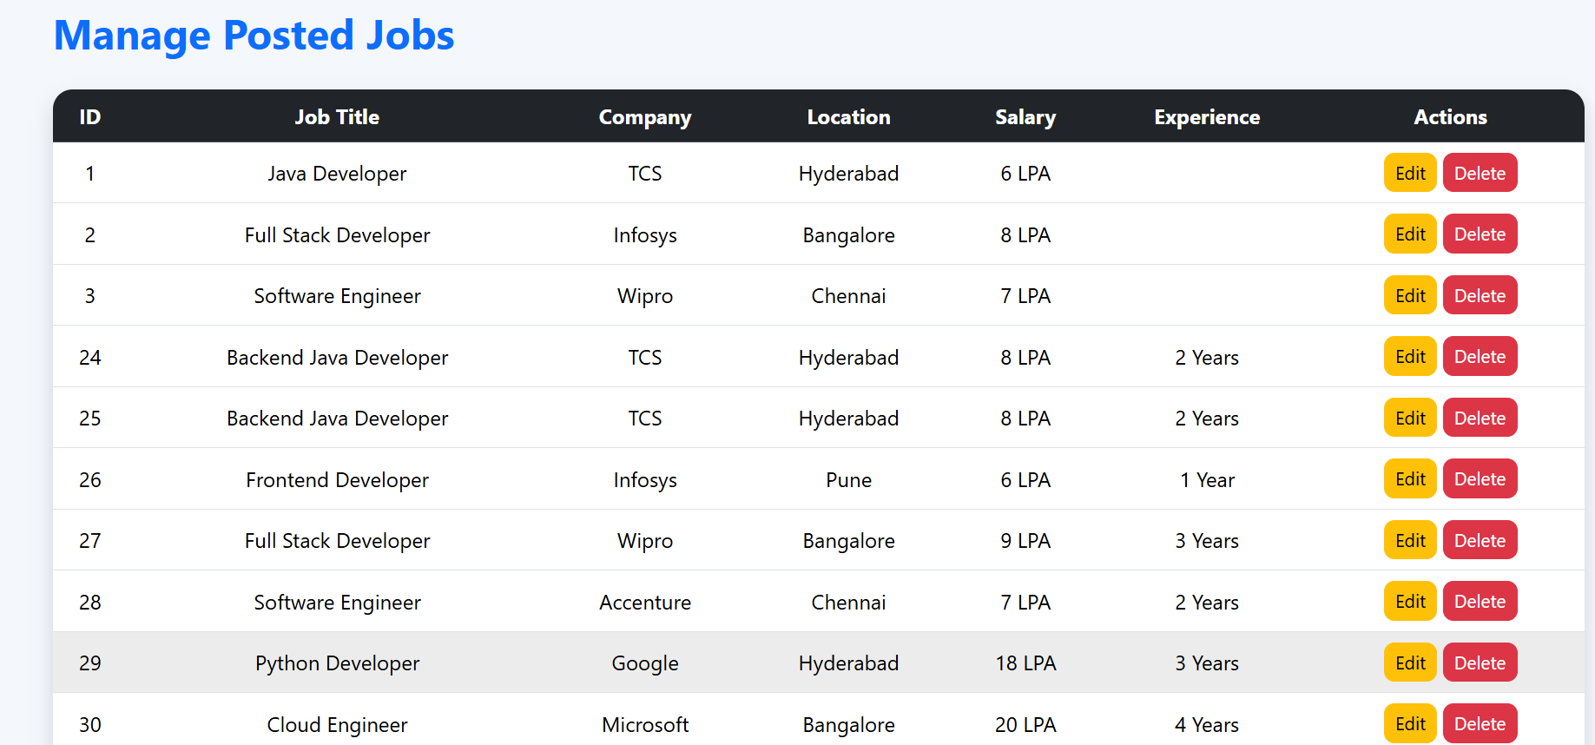

Admin Job:

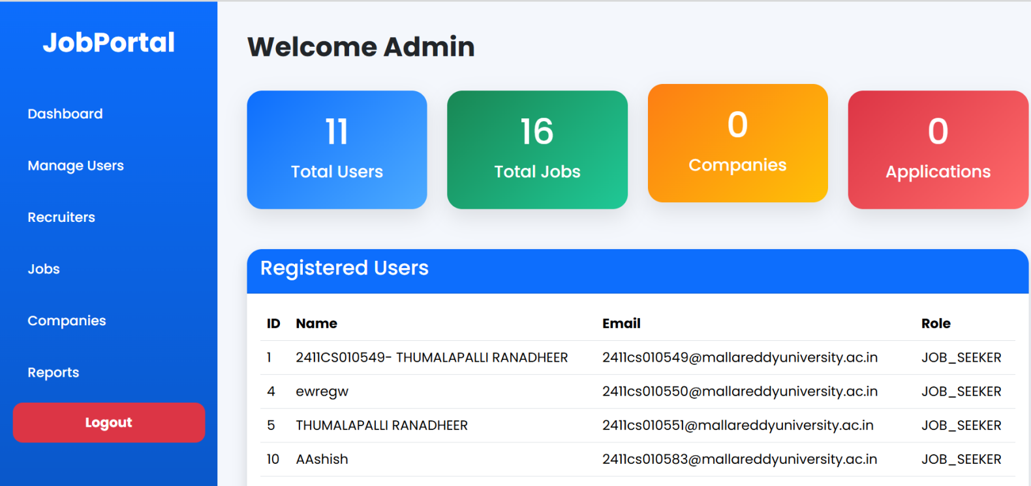
9.Results
The Job Portal Management System was successfully designed, developed, and tested using Java, Spring Boot, Spring MVC, Spring Security, Thymeleaf, HTML, CSS, Bootstrap, JavaScript, and MySQL. The application provides a secure and user-friendly platform that enables administrators, recruiters, and job seekers to perform their respective tasks efficiently through role-based authentication.
The system successfully supports user registration and login, company profile management, job posting, job searching, online job applications, and applicant management. Recruiters can create and manage job vacancies, while job seekers can search for suitable jobs, apply online, and track their application status. Administrators can effectively manage users, recruiters, companies, job categories, and job postings through an administrative dashboard.
Testing confirmed that all major modules function correctly without significant errors. Data is stored securely in the MySQL database, and Spring Security ensures password encryption and secure access control. The application demonstrates good performance, reliable database connectivity, and a responsive user interface across different web browsers.
The developed system successfully achieves the project objectives by reducing manual recruitment activities, improving communication between recruiters and candidates, minimizing paperwork, and providing a centralized recruitment platform.

10 .Conclusion
The Job Portal Management System has been successfully designed and implemented as a secure, efficient, and user-friendly web application that simplifies the recruitment process for administrators, recruiters, and job seekers. The system effectively automates essential recruitment activities such as user registration, secure login, company profile management, job posting, job searching, online job applications, and applicant management. By providing a centralized platform, it eliminates the limitations of traditional recruitment methods, reduces manual paperwork, and improves the overall efficiency of the hiring process.
The application is developed using modern technologies including Java, Spring Boot, Spring MVC, Spring Security, Thymeleaf, HTML, CSS, Bootstrap, JavaScript, and MySQL. The implementation of role-based authentication and authorization ensures secure access to the system, while the MVC architecture improves maintainability, scalability, and code organization. The MySQL database provides reliable storage and retrieval of user information, company details, job postings, and application records.
Testing confirms that all modules function correctly and meet the project objectives. The developed system provides a responsive interface, secure data management, and efficient communication between recruiters and job seekers. Overall, the Job Portal Management System serves as a practical solution for modern online recruitment and demonstrates the effective application of enterprise Java technologies in web development. The project can be further enhanced by integrating advanced features such as AI-based job recommendations, resume screening, interview scheduling, email notifications, and analytics dashboards, making it suitable for large-scale real-world recruitment applications.
窗体顶端

窗体底端

